Running Bitcoin Core on the Command Line (Part 1)
Whether you think Bitcoin is worth $1M, or $0, I’m not going to debate that here. Based on its volatility, it’s hard to know whether the world will get behind it, and that it can one day be a reliable store of value. Regardless, the notion that you can set up a Bitcoin full node at home and more or less “be your own bank” has much appeal. And the technology is undeniably cool, albeit challenging. So this article goes into some of the more tricky parts I experienced while setting up my own Bitcoin full node in Ubuntu Linux 18.04.
The Machine
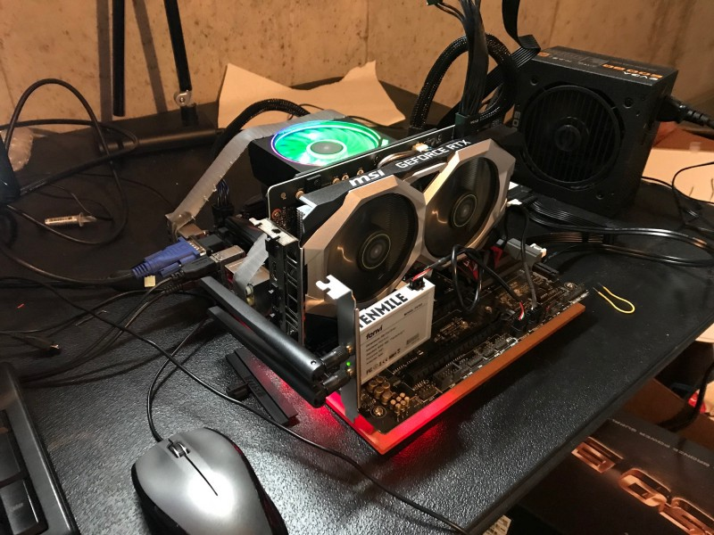Bitcoin Full-Node Testbed
I assembled the machine from the skeletal remains of an Ethereum miner bought off a friend, and miscellaneous parts I had lying around.
- Intel G4500 3.5GHz dual-core CPU
- ASUS motherboard with Intel Z170 chipset
- 16GB of G-Skill 2400 MHz RAM
- Inland 1TB SSD
- Intel 9260 802.11ac wireless card
- Nvidia RTX 2060 Super GPU; unrelated, but bad-ass
- And yeah, that’s an AMD fan cooler taped to the CPU, what of it?
Hard Drive Considerations
The Bitcoin blockchain is enormous (about 300GB as of 6/10/2020). And my quaint Linux box was running on an old Sandisk 128GB SSD. So I decided to move from 128GB to a 1TB SSD. The constant read/write of the Blockchain requires that you use an SSD rather than HDD, unless you want to run the risk of the drive failing. Not a big issue, presuming you back up your wallet and keys in a safe place — which I am still suggesting you do — but the SSD feels safer, and it is certainly more energy efficient and compact.
To merge the contents of my 128GB drive onto the 1TB SSD, here’s the tutorial I followed:
How to clone a Linux Hard Drive with Gparted
Duplicating hard drive partitions can be tedious if you use a tool like Clonezilla or another Linux-backup utility. If…www.addictivetips.com
In brief, the process requires:
- Creating a bootable USB thumb drive of the Gparted ISO utility
- Installing both hard drives into your machine
- Booting from thumb drive into gparted
- “Pasting” the boot and OS partitions of the original drive to the new one. Concurrently, you expand/resize the OS partition on the target drive to reflect the increased size.
In all, I was really satisfied with the gparted utility. In the future I will use it for my ambitious goal of hard drive hygiene: keeping the OS on a separate partition from my general files, to permit clean OS installs [if necessary] during an update. But what can I say, I’m a slob, and my hard drive is currently as messy as my office. We’ll put it down as a “stretch goal.”
Software Installation
I am not going to go through the whole ritual for installing Bitcoin Core, you can get a pretty good description of what you need to do from here: https://bitcoin.org/en/full-node#linux-instructions. The remaining parts of the article are me filling in the blanks, and some amendments to the technique.
Bitcoin Core Installation Quirks
To ensure that you have a genuine copy of the Bitcoin Core software (read: very important), you want to do an SHA checksum on the file you download, to ensure no would-be thief has injected malware into it. I will point out that it was not completely obvious how to do the checksum at first. Absent clear instructions, here’s the method I adapted for it.
- Your Ubuntu install should have a utility called shasum, which can be used to verify the file’s integrity. Check that you have it:
$ which shasum
# output:
/usr/bin/shasum
$ shasum -v
# output:
5.96
- Next, download and uncompress the Bitcoin Core source file. Once the file is downloaded, open a terminal window and use the following command to unpack the file:
$ tar xzf bitcoin-0.20.0-x86_64-linux-gnu.tar.gz
- Download the SHA 256 checksums file to compare the computed checksum to. The file I used was called SHA256SUMS.asc. You can get it from clicking the link labeled “verify release signatures” on the Bitcoin Core download page. Be sure you get the file from the legitimate source (e.g. bitcoin.org), otherwise I am sure it’s as good as nothing.
- Check the SHA sum:
$ cat SHA256SUMS.asc | grep bitcoin-0.20.0-x86_64-linux-gnu.tar.gz | shasum --algorithm 256 --check
- If the file has not been tampered with, you should get an “OK” result as follows:
# output:
bitcoin-0.20.0-x86_64-linux-gnu.tar.gz: OK
Once that is done, it’s very fast and straightforward to get the software installed:
$ sudo install -m 0755 -o root -g root -t /usr/local/bin bitcoin-0.20.0/bin/*
After the software is installed, which happens almost instantly, you’ll probably need to close the terminal and reopen it.
Launch on Startup
I think it’s a good idea to have the bitcoin node activated upon startup. Get that done by adding it to the cron schedule:
$ crontab -e
# add the following line
@reboot bitcoind -daemon
# ctrl + C; Y to save and exit
Syncing the Blockchain
At this point we’re ready to launch. Make sure you don’t have anything else to do with the computer for a few days. It’s going to take awhile. And this is where that 802.11ac wireless card (or gigabit ethernet port) comes in handy. Faster internet equals faster sync time, obviously.
All we need to do is start Bitcoin Core:
$ bitcoind -daemon
If you want to see how your node is progressing you can check the progress (output: 0–1 = 0–100%):
$ bitcoin-cli getblockchaininfo | jq .verificationprogress
# output:
0.9999973303358778 # > 0.99999 you are fully synced
If you want a human-readable estimate of the blockchain size on your disk, try:
$ ls -lah ~/.bitcoin/blocks | head -n 1
# output:
total 299G
For a list of command to get you started:
$ bitcoin-cli help
In the next article I will walk you through setting up and using wallets in Bitcoin Core on the command line. There are numerous pitfalls here and, depending on the sums of money you are dealing with, these may come with significant consequence. I wanted to break that piece out and make sure that I did it right. So stay tuned for Part 2!

